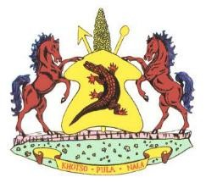
Lesotho permit number…………………………………….

VETERINARY HEALTH ATTESTATION FOR PIES

I……………………………………………………………………………………………………………..the undersigned veterinary/official authorized by the Director of Veterinary Services in South Africa attest the following:
- That the meat pies are of South African origin, or produced from meat product legally imported into South Africa;
- The establishment from which the products originate is regularly inspected by government public health officials in the country of origin;
- The meat pies must be transported in containers , which are made in such a way as to prevent contamination of the products by disease causing agents;
- The vehicle transporting meat pies must conforms to acceptable standard of cleanliness, construction, maintenance; and be equipped with a continuous registering thermograph;
- The meat pies must be loaded and sealed under the supervision of authorized officials and the seal number is indicated on the international veterinary certificate for export.

Seal No………………………………………………………………………………….

Vehicle No……………………………………………………………………………..

- The exporter/importer has been informed to undertake to inform the government veterinary officials nearest to the point of destination, so that she/he could unseal and check the consignment before it is disposed of in any way.
- The permit is valid for 30 days from date of issue and is for one consignment only.
Signed at……………………………………………………………………… On date………………………………………………………………………
_____________________________________________
Authorized Veterinary /Official
Name in print…………………………………………………………………..
Designated Rank……………………………………………………………….
Address…………………………………………………………………………….. Official Stamp

